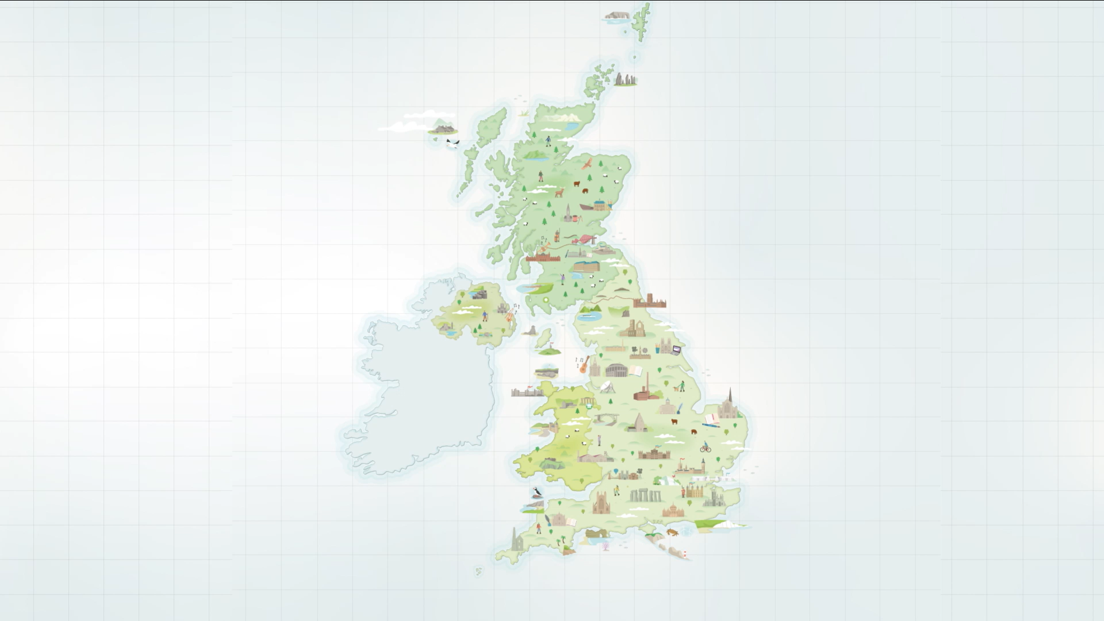

**Discover the UK’s UNESCO Sites map**

**2023 Summer campaign**

**Evaluation report**

**UK National Commission for UNESCO**

Contents

Introduction 3

Discover the UK’s UNESCO Sites 3

The four key goals and headline achievements 3

Project overview 4

Personnel index 4

Work Breakdown Structure 5

Timetable of activities 6

Budget 8

Key findings 9

Overview 9

Limited print run of the map 10

Social media post reach from UK National Commission for UNESCO 11

Interactive map webpage data 13

Key partners 17

Conclusion 18

Appendices 19

# Introduction

## Discover the UK’s UNESCO Sites

*“people’s awareness of UNESCO designations in the UK is generally low and some [designations] are more well-known than others”.*

- Extract from the UK National Commission for UNESCO’s *National Value of UNESCO to the United Kingdom* report (2019, Appendix 1)

*Discover the UK’s UNESCO Sites* was a 7-week creative social media and press marketing campaign in Summer 2023 led by the UK National Commission for UNESCO in partnership with Visit Britain and supported by GREAT and the National Lottery Heritage Fund, thanks to National Lottery players. The centrepiece of the campaign was a brand new illustrated map designed by the Birmingham-based cartographer, Tom Woolley. The map highlighted all 58 land-based UNESCO designations in the British Isles through illustrated depictions of iconic landmarks and place names. The UK National Commission for UNESCO commissioned a team of designers and creatives to bring the map to life as an interactive digital version; an animated short film flyover of the map; a series of social media posts and stories; a limited print run of 25,000 hardcopies of the map distributed to sites and translated versions of the map in the 7 priority languages of Visit Britain; Arabic, Dutch, French, German, Italian, Spanish and Welsh.

The purpose of the *Discover the UK’s UNESCO Sites* campaign is to raise awareness across the population of the British Isles and overseas visitors about the 58 site-based UNESCO designations in the UK (World Heritage Sites, Global Geoparks, Biosphere Reserves and Creative Cities). The map is designed to encourage more visits to these sites, in particular the lesser known designations. The map, like UNESCO designated sites, is to be enjoyed by all the peoples of the world but the primary audience is likely to be those with an existing interest in culture, heritage, geology, the environment and UNESCO.

The key messages of the map and accompanying campaign were “Discover”, which is the main theme for the national press release and initial social media posts and “Did you know that …”, which is a follow up series of social media posts, e.g. “Did you know that the UK is home to 58 UNESCO sites? Find them all on our new Discovering UNESCO in the UK map” (then other variations specific to type of designation, the 4 nations of the UK).

## The four key goals and headline achievements

* **Deliver an original product and promotional campaign that encourage people to visit and explore the UK UNESCO network**

At least 30 independent press articles (Appendix 4) were published on the map, driving users to the interactive map which received 36,397 total views from 27,387 individuals since its launch. Average daily visitors to the UKNC website (1,411) rocketed 600% compared to the four weeks prior (234).

* **Leverage the power of the network to maximise groundswell and interest in the map across social media**

64.4% of visits to the digital map came from organic social media or webpage referrals, which suggests that the network played a vital role in driving interest and engagement with the map. The accompanying social media campaign had a minimum 2,125,136 impressions worldwide resulting in 19,794 total engagements across UKNC and key partner channels. The majority of the 52,955 viewers watched 96% of the short film. This is a conservative estimate taken from data collected by the project lead and primary partners and the overall reach is highly likely to be greater than this.

* **Especially promote the map to international audiences including priorities languages of Visit Britain**

The UKNC worked with a translation agency and designers to produce multilingual maps, press releases and social media posts in the 7 priority languages of Visit Britain (Arabic, Dutch, French, German, Italian, Spanish and Welsh). As a result, 38.4% of digital map users were from outside the UK while 27.1% accessed the map in a first language other than English.

* **Encourage deeper understanding of the diversity of UNESCO sites in the UK network**

2,725 click throughs from the main interactive map hosted on the UKNC website to individual sites webpages. The top 20 most popular sites demonstrated good range of geographies and designation types. An average engagement time of 43 seconds on the UKNC website and 113 second on the National Lottery Heritage Fund website, while 52,955 viewers of the short film on average watched 44 seconds or 96% of the film. This suggests high quality engagement with the digital map.

# Project overview

## Personnel index

|  |  |
| --- | --- |
| 1. Alison Smedley Project Administrator, UKNC 2. Andrea Mayne Head of Finance and Accreditation, UKNC 3. Andrew Mailing IT Support, UKNC 4. Blackfish Freelance printer agency 5. BlowUp Freelance web design agency 6. Charlie Kennedy   Communications and Information Officer, UKNC   1. Dan Lusby Freelance motion graphic designer 2. Irfan Ul-Haq Freelance graphic Designer 3. James Bridge Chief Executive and Secretary-General, UKNC 4. Kerry O’Coy Freelance PR consultant | 1. Liam Smyth Project Implementation Manager, UKNC 2. M4 Translation Freelance translation agency 3. Matt Rabagliati   Head of Policy, Research and Communications, UKNC   1. National Lottery Heritage Fund Joint-funder of project 2. Nikki Mills Freelance voiceover artist 3. Richard Berry Freelance graphic designer 4. Tom Woolley Freelance illustrator 5. UKNC Network 58 Sites with UNESCO designated status in the British Isles 6. Visit Britain National Tourism Agency for UK |

## Work Breakdown Structure

|  |  |  |  |  |  |  |  |
| --- | --- | --- | --- | --- | --- | --- | --- |
| **Deliverable** | **Description** | **Sub deliverables** | **Responsibility** | | | | |
| Map creation |  | Content cataloguing (images, copy, web links, etc.) | K | A | M | R |  |
| Design and development of illustrated map | Q |  |  |  |  |
| Design of map index | Q | P |  |  |  |
| Production of print-ready and digital versions of map | P |  |  |  |  |
| Digital map creation |  | Design and conceptualisation of interactive webpage | E |  |  |  |  |
| Publishing of webpage | E |  |  |  |  |
| Training and development | E |  |  |  |  |
| Monitoring and maintenance of web page | E | F | C |  |  |
| Map launch - Social media campaign and press promotion |  | Prep press pack and marketing timeline | K | J |  |  |  |
| Drafting of press release and sourcing quotes | K | A | L | I |  |
| Communication with partners | K | J | I |  |  |
| Social media posts | K | F |  |  |  |
| Press list and comms | K | A | J |  |  |
| Paid promotions | K | B | F |  |  |
| Print request form opened and responses collected | K | M |  |  |  |
| Print and P&P of hardcopies of maps | D | A |  |  |  |
| In-person presentations | K | I |  |  |  |
| Animated film |  | Script development | K | Q | G |  |  |
| Script translation | L | O |  |  |  |
| Storyboarding | Q | G |  |  |  |
| Audio selection and mixing | K | J | Q | O |  |
| Voice over recording | O |  |  |  |  |
| Film production | G |  |  |  |  |
| Multilingual translation of map |  | Coded map and spreadsheet | K |  |  |  |  |
| Translation of map copy, press release and social media posts | L |  |  |  |  |
| Crosschecking designation translations with UKNC | I |  |  |  |  |
| Design of Dutch, French, German, Italian, Spanish and Welsh maps | P | Q |  |  |  |
| Design of Arabic map | H | Q |  |  |  |
| Monitoring and Evaluation |  | Digital audience data collection | K | A | J |  |  |
| Data analysis | K |  |  |  |  |
| Financial management | B | K |  |  |  |
| Financial reporting | B | K |  |  |  |
| Prep letters of agreement with freelancers | K | B | I |  |  |
| Project reporting | K |  |  |  |  |

## Timetable of activities

|  |
| --- |
| Key milestones highlighted in yellow |
| UKNC Social media posts highlighted in blue |

|  |  |  |  |
| --- | --- | --- | --- |
| **Project phases** | **Activity** | **Date from** | **Date to** |
| Conception and initiation | Sign off from GREAT and the Heritage Fund on original funding to design and deliver map illustration | **10 Mar** | **10 Mar** |
| Content cataloguing from network (images, copy, web links etc.) | **5 Apr** | **22 Jun** |
| Design, development and production of original map illustration | **5 Apr** | **29 Jun** |
| Development and submission of second fundraising application to GREAT | **10 May** | **6 Jun** |
| Sign off on second phase of map development from GREAT and the Heritage Fund | **10 Jun** | **10 Jun** |
| Planning | Print request form sent out and responses collated | **10 Jun** | **26 Jul** |
| Write up of press release and sourcing of diplomatic quotes | **10 Jun** | **19 Jun** |
| Onboarding of map development team (E, G, H, L, P, Q, S) with letters of agreement written up and countersigned | **1 Apr** | **18 Jun** |
| Design, develop and publishing of new interactive map web page | **18 Jul** | **11 Aug** |
| Press list written up and contacted | **1 Jun** | **24 Jun** |
| Press pack development and delivery to all stakeholders | **1 Jun** | **24 Jun** |
| Pre-launch meeting with UKNC network | **19 Jun** | **19 Jun** |
| Execution | Map is officially launched with posts across all social media | **24 Jun** | **24 Jun** |
| UKNC receive training in interactive digital map maintenance | **25 Jul** | **25 Jul** |
| Significant period of press activity | **24 Jun** | **25 Jul** |
| Short film script developed and signed off | **12 Jul** | **19 Jul** |
| Short film storyboarded, audio and voiceover artist selected | **5 Jul** | **2 Aug** |
| Short film developed and published | **28 Jul** | **18 Aug** |
| Script, press release, social media copy and copy from the map coded and translated by external agency | **24 Jul** | **17 Aug** |
| Translation of UNESCO designation types cross-checked with six other National Commission Secretary Generals | **1 Aug** | **17 Aug** |
| Voice over recorded in Welsh and English | **2 Aug** | **12 Aug** |
| Short film launches with posts across all social media | **18 Aug** | **18 Aug** |
| Maps printed and posted out to all sites | **7 Aug** | **14 Aug** |
| Translated versions of the map launched with posts across all social media | **28 Aug** | **3 Sep** |
| Presentation of the map to global national commissions at UNESCO HQ in Paris | **10 Oct** | **10 Oct** |
| Monitoring and control | Digital audience and finance data collection | **3 Sep** | **10 Sep** |
| Data analysis and financial reporting | **10 Sep** | **10 Oct** |
| UKNC Project report write-up | **30 Sep** | **10 Oct** |
| Project close | Confirmation from GREAT on receipt of evaluation | **14 Oct** | **14 Oct** |
| UKNC report published with blog to UKNC network | **Early** | **Nov** |

## Budget

|  |  |  |
| --- | --- | --- |
| **Project Costs** | **Service Provider** | **Expenditure** |
| **Map creation** | **Tom Woolley** | **2,000.00** |
| **Website creation** | **BlowUp Holding Ltd** | **3,000.00** |
| **Social Media Paid Promotion** | **Instagram and Facebook** | **237.36** |
| **Videographer** | **Daniel Lusby** | **2,100.00** |
| **Asset Design & Translated Map Design** | **Tom Woolley Illustration** | **2,000.00** |
| **PR Professional** | **Kerry O'Coy/Fused** | **3,000.00** |
| **Voice-Over for Videos** | **Fiverr** | **385.68** |
| **Translation into VB Target Languages** | **Manchester City Council Communications & Language Support Services** | **4,699.97** |
| **Print and P&P** | **Blackfish** | **4,830.00** |
| **Contingency** |  | **1,201.99** |
| **Total** | | **23,461.00** |

# Key findings

## Overview

The *Discover the UK’s UNESCO Sites* project began on 10th March with the commissioning of the illustrated map by Tom Woolley. A subsequent summer campaign ran for 7 weeks from 24th July to 8th September 2023. In this time, UKNC delivered the following outputs:

* A brand new illustrated map created by Tom Woolley presenting all 58 land-based UNESCO designated sites in the British Isles
* 25,000 hardcopies of the map printed and posted to 30 UNESCO sites that requested copies
* A new interactive digital map resource hosted on the UKNC website
* An 45-second animated promotional short film demonstrating a flyover of the illustrated map
* Seven translated versions of the map in Arabic, Dutch, French, German, Italian, Spanish and Welsh, available to download from the UKNC website
* A press pack for all sites and partners to use that contained a tip sheet, example social media posts, media files and press releases to support as many people as possible to take part in the campaign
* 56 social media posts promoting the launch of the map
* Additionally, all sites and partners also put out social media posts that contributed to a groundswell of interest online
* This evaluation report and accompanying slides

UKNC and its partners, Visit Britain and National Lottery Heritage Fund, monitored digital audience data over the 7 week campaign. The key findings in this report are drawn from these data sources. This is an incomplete picture as we know from web scraped data and anecdotal evidence that many sites in our network also contributed their own social media posts. Further, partners in our extended network such as British embassies worldwide, other national commissions for UNESCO, ministers and professional peers also published their own posts. UKNC did not have the capacity to capture all of this additional data from our extended network and chose to focus on the reliable data sources from the project lead (UKNC) and key partners (Visit Britain and National Lottery Heritage Fund). Therefore, we can say that the minimum total engagement metrics for this summer’s social media campaign was as follows:

* 1,319,905 total reach
* 1,935,136 total impressions
* 17,503 total engagements

And the minimum engagement on newly created webpages featuring the map was as follows:

* 36,135 total views
* 28,387 unique users

## Limited print run of the map

Additionally to the digital engagement that we have reported on, 25,000 hardcopies of the map were produced and sent to all 30 sites that requested printed versions through our online request form. The maps were printed using sustainable paper sources and only sent to sites that requested them so we could be sure that they would be distributed them responsibly. Each map includes a request for users to share the map with a friend or recycle it after using.

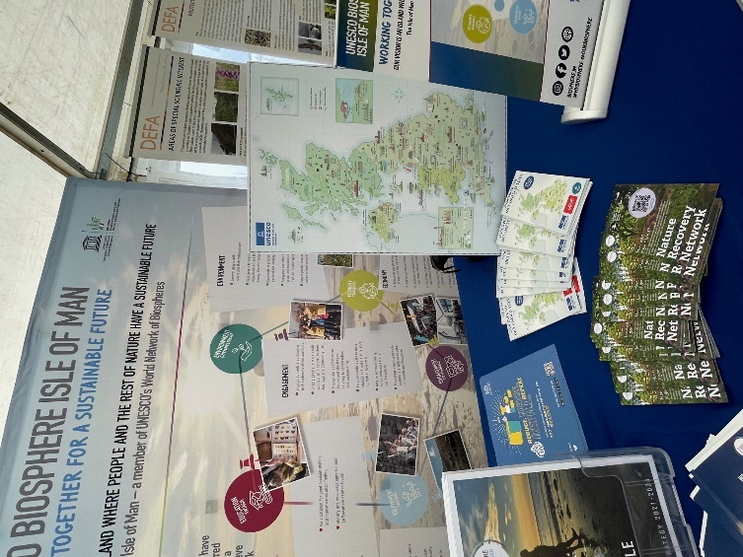

Figure : Examples of the printed hardcopy of the map out on location in situ at a selection of UNESCO sites in the UK

Press promotion

The UKNC commissioned freelance PR consultant, Kerry O’Coy to finalise the press release (Appendix 2) and bring together a press pack (Appendix 3) for the UK UNESCO network and project partners to use in promoting the launch of the map. Demonstrating how well received the map had already been with ministers from England, Scotland and Wales (the government for Northern Ireland was not sitting at the time of publication) and national funders. The press release contained quotes from:

* Andy Pike, GREAT Campaign Director
* John McGrillen, Chief Executive of Tourism Northern Ireland
* Lord Parkinson of Whitley Bay, Minister for Arts & Heritage in the UK Government
* Mark Drakeford, First Minister of Wales
* Richard Lochhead MSP, Minister for Small Business, Innovation, Tourism and Trade
* Stuart McLeod, Director of England - London & South at The National Lottery Heritage Fund

## Social media post reach from UK National Commission for UNESCO

On social media, promotional posts from the UKNC’s accounts had the following impact:

* 955,115 reach
* 1,289,766 impressions
* 14,663 engagements

Arguably our best performing channel was Instagram, which gave UKNC 55% of its overall reach and impressions. UKNC have the most followers on Instagram (35.7K) compared to any of their other social media channels but even here, the impact of the map launch was felt significantly. Over the course of the summer campaign, total engagement figures on Instagram (3,945) rose 1,070% compared to the previous month.

Meanwhile, when it came to the short film, 52,955 people viewed the film online across multiple channels. According to YouTube analytics, which accounts for the largest single proportion of views on all channels, the average viewer watched 44 seconds or 96% of the film. This points towards high quality depth of engagement, with the short film content successfully retaining the vast majority of viewers for the total film length.

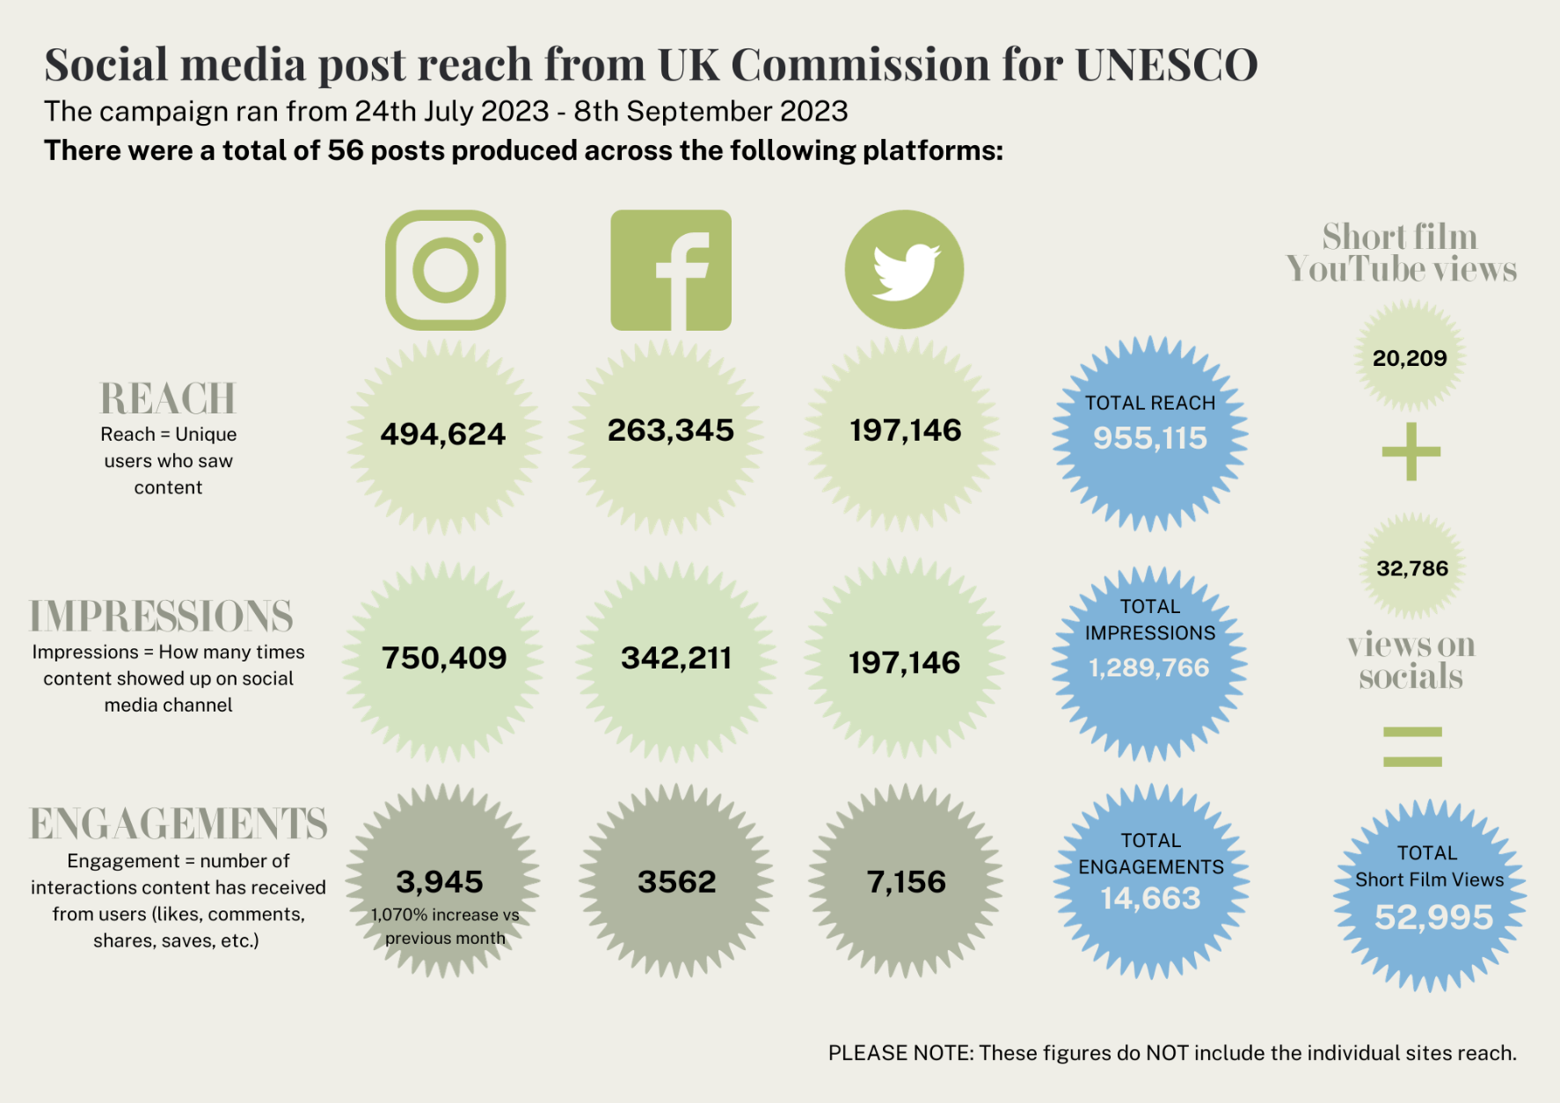

Figure : Data collected by UKNC on posts from their own social media channels

## Interactive map webpage data

The *Discover the UK’s UNESCO Sites* interactive map webpage had the following engagement on the UKNC website:

* 32,846 total views from 25,098 individuals of the interactive map since its launch with an average engagement time of 43 seconds
* 2,725 click throughs from the map to individual sites webpages with the top 20 most popular sites demonstrating good range of geographies and designation types
* 38.4% of users were from outside the UK with 27.1% who have a first language other than English

As a benchmark, the web traffic on the UKNC website for the four weeks prior to the launch of the map was 234 average daily visitors. For the four weeks post the launch of the map, web traffic numbers vaulted to 1,411 average daily visitors, representing a 600% increase. This includes the highest 7-day period of web traffic data which peaked at 5,083 daily visitors on Sunday 30th July.

Figure : Graph showing spike in web traffic data between 24th – 31st July 2023 in the first week of the map’s launch

However, even with this early 7-day spike removed, average web traffic plateaued at 500 average daily visitors – more than double the benchmark figure prior to the map’s launch. This suggests that although the initial press promotion and social media coverage (see above) triggered an initial explosion in increased activity, the overall trend in long-term engagement has been positive.

Importantly, the quality of engagement has also been good. The average engagement time for users was 43 seconds since the map launched. This was even higher during the 7-day spike when web traffic was highest. At this point, the average engagement time was 80 seconds.

It is also useful to note where from and how people reached the map. The digital map was successful in engaging international and multilingual audiences. 38.4% of digital map users were from outside the UK while 27.1% accessed the map in a first language other than English. Google Analytics does not collect data on Welsh language speakers but we do know that 12.5% of all users accessed the map in one of the other six priority languages of Visit Britain.

The above data should be read with caution, as there is evidence that suggests that the data on language and country of residence could be misleading. Firstly, the user data on country of residence could be overestimated. Here, users from 151 different countries outside of the UK were logged. This seems excessive even for an International Cultural Relations organisation and could be down to VPNs disguising the true country of residence for some users. Secondly, the number of users accessing the map in a language other than English could be an underestimation. For example, despite 589 (2.34%) of visits from Arabic-speaking nations, only 177 (0.7%) were identified as speaking Arabic, which could suggest the presence of bilingual users being logged mistakenly as English speakers. Likewise, as previously mentioned Google does not log Welsh-speaking users.

Lastly, the routes by which users reached the map point towards the power of the partners in generating groundswell and web traffic towards the map. 64.4% of visits to the digital map came from organic social media (34.4%) or webpage referrals (30%), which suggests that the network played a central role in driving web traffic to the map.

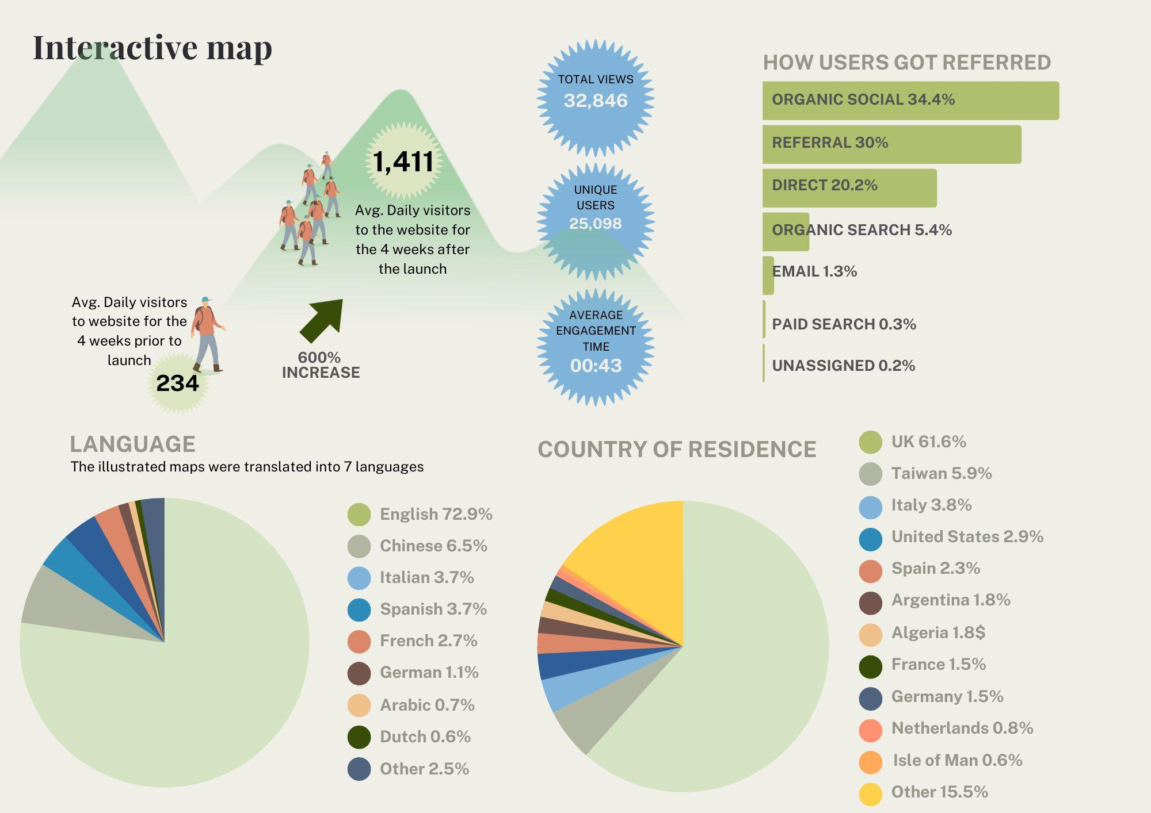

Figure : Data collected by UKNC on the digital interactive map

The success of the map cannot purely be based on web traffic to the map itself. The purpose of the map of course is to signpost to users to the 58 UNESCO sites in the UK network, with a short profile and web link to each site in the index. The digital map allows us to collect data on how many users click through to each site’s own websites. This is of course not the only way that visitors can access the individual websites of each but we can still glean useful insights using our own website’s Google analytics. Over the course of the 7-week campaign there were 2,725 total click throughs from UKNC’s digital map to individual websites of sites across our network. In monitoring the breadth of click throughs, the map appears to be directing web traffic to a good spread of different designation types in our network in urban, rural and coastal environments across the regions and the four nations of the UK. Interestingly, none of the sites that appear in the top 20 of click throughs received are based in the capital cities of the UK. This suggests that the map has been successful in encouraging a deeper understanding of the diversity of UNESCO sites in the UK network.

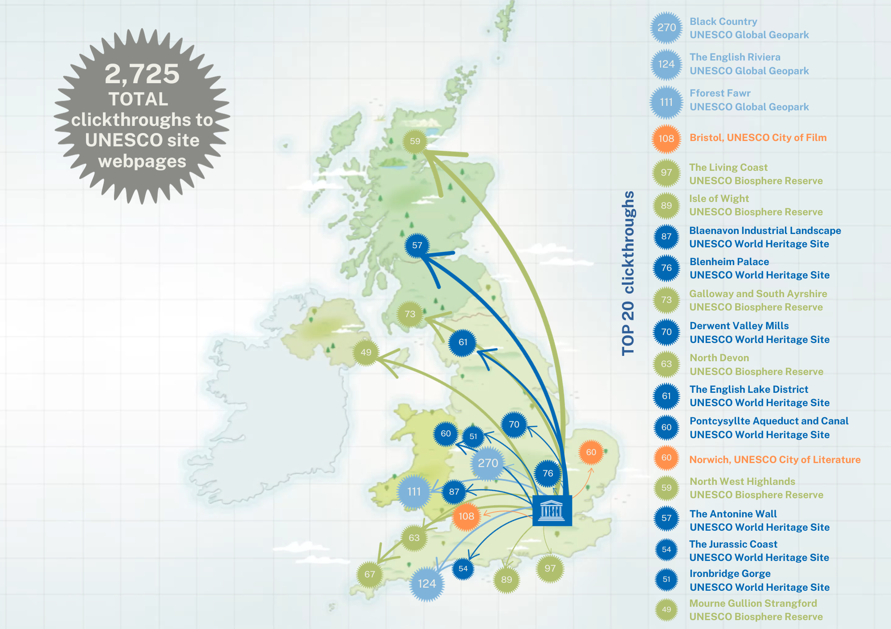

Figure : Data collected on the interactive map's click through rate across all sites in the network

## Key partners

On top of the UKNC’s own website and social media channels, our project partners Visit Britain and National Lottery Heritage Fund also published original posts and collected comparable data. Visit Britain’s social media posts recorded the following impact:

* 436,790 reach
* 645,370 impressions
* 2,840 engagements

And their website had 1,000 web page views for their heritage cities page, which hosts a link to our interactive map. This is marginally higher than comparable pages.

The National Lottery Heritage Fund’s social media posts recorded the following impact:

* 190,000 impressions
* 2,291 engagements

And their website had 2,551 views and 2,289 unique users to the web page, which hosts the press release and a link to our interactive map. This is a 830% increase on their benchmark for web traffic of 275. Finally, the average dwell time for the web page was an extraordinary 133 seconds.

The UK Government included the interactive map as an example best practice guidance in their [Building Digital UK guide.](https://www.gov.uk/guidance/building-digital-uk-environmental-resource-guide-august-2023)

It was not possible to collect the abundance of social media statistics from our network of 58 sites and wider secondary partners in full. However, as an example of the undocumented impact across the extended network, the UKNC team collected 18 medium-to-high performing social media posts and found these to have had 1,163 total engagements. Extrapolated out, this would mean an additional 64 engagements for each social media post among the extended network.

# Conclusion

The campaign was able to achieve the following outcomes against the four primary goals of the project:

* **Deliver an original product and promotional campaign that encourage people to visit and explore the UK UNESCO network**

36,397 total views from 27,387 individuals of the interactive map since its launch across UKNC and key partner websites. An average engagement time of 43 seconds on the UKNC website and 113 second on the National Lottery Heritage Fund website.

* **Leverage the power of the network to maximise groundswell and interest in the map across social media**

The social media campaign had a minimum 2,125,136 impressions worldwide resulting in 19,794 total engagements across UKNC and key partner channels. The majority of the 52,955 viewers watched 96% of the short film.

* **Especially promote the map to international audiences including priorities languages of Visit Britain**

38.4% of users were from outside the UK with 27.1% who have a first language other than English

* **Encourage deeper understanding of different UNESCO sites in the UK network**

2,725 click throughs from the main interactive map hosted on the UKNC website to individual sites webpages. The top 20 most popular sites demonstrating good range of geographies and designation types

Going forward, Visit Britain’s channels in Spain, Germany, The Netherlands and France plan to continue promoting the map on socials until the end of this year. Likewise, the UK National Commission for UNESCO will continue to promote the map and network nationally and internationally with three public speaking arrangements made for September and October 2023 with the National Commissions for UNESCO in Iceland and Norway and at the international secretary generals conference at the UNESCO headquarters in Paris.

# Appendices

## Appendix 1: National Value of UNESCO to the United Kingdom (2019)

<https://unesco.org.uk/national-value/>

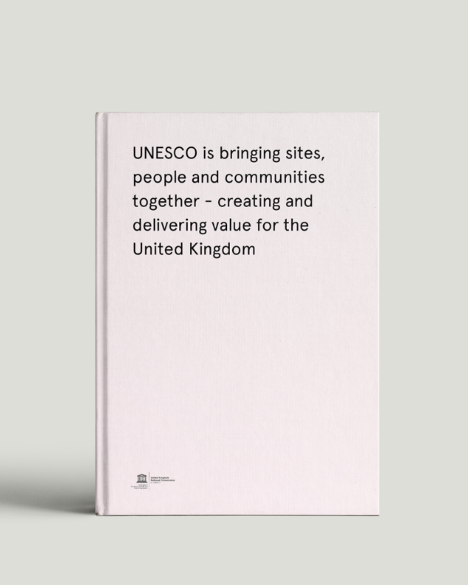

## Appendix 2: Press release (English)

PRESS RELEASE - NATIONAL PRESS

**DISCOVER 58 UNIQUE UK UNESCO SITES ON NEW ILLUSTRATED MAP**

*Release Date (embargoed until): 24 July 2023*

* *New map launched that includes all 58 UK UNESCO sites for the first time*
* *Map illustration by artist Tom Woolley*
* *Visitors encouraged to discover new sites and destinations on their doorstep*

Ignite your summer adventures and discover 58 unique UNESCO sites in the UK and crown dependencies thanks to a newly illustrated map, now available to download for free from the UK National Commission for UNESCO.

From expansive mountain ranges and stunning coastlines to vibrant cities and rural landscapes - the UK's UNESCO sites are destinations of world-class natural and cultural heritage. For the first time a map, designed by Birmingham-based creative cartographer *Tom Woolley*, brings together all of the Biosphere Reserves, Creative Cities, Global Geoparks and World Heritage Sites across the British Isles that are waiting to be discovered.

Visitors to the sites are invited to immerse themselves in the spectacular vistas of the slate landscape of Northwest Wales or the Scottish Highlands. Dive into the literary heritage of Manchester or Edinburgh. Scale the mountains of the English Lake District or the peaks of Fforest Fawr. Uncover legends and folklore along the Giant's Causeway or Stonehenge. Breathe in the sea air of Brighton and Lewes, North Devon or the English Riviera. Tackle the northernmost frontiers of the Roman empire by foot or by bike. Stroll around one of the great spa towns of Europe in Bath or a landed estate at Blenheim Palace. And dance the night away in an iconic concert hall in Belfast or at a festival under the stars at one of the world's largest deep space observatories at Jodrell Bank.

The new map, released online this week, includes 29 World Heritage Sites, 13 Creative Cities, 9 Global Geoparks and 7 Biosphere Reserves that cover 13% of the UK’s landmass. Most of the sites are free to enter and conveniently accessible by public transport offering the public new experiences to discover UNESCO sites in the UK and mark this summer with a visit to one of the world’s most special places.

James Bridge, Chief Executive and Secretary-General of the UK National Commission for UNESCO said: *“This new UNESCO in the UK map will inspire people for places to visit. It shows at a glance the breadth of amazing natural, cultural and built heritage designated by UNESCO as internationally significant in the UK. This great map highlights places to explore, on your doorstep and further afield, both the famous and those to discover for the first time.”*

First Minister of Wales, Mark Drakeford said: *“I’m immensely proud that Wales is home to four UNESCO World Heritage Sites. This new map beautifully illustrates our world class destinations, and as we continue to protect these sites, their significance will be enjoyed by generations to come. Wales is an open and welcoming nation, one that invites the world to discover our natural wonders, culture and heritage which UNESCO sites have to offer.”*

Lord Parkinson of Whitley Bay, Minister for Arts & Heritage in the UK Government said: *"The UK is home to so many extraordinary cultural and natural heritage sites – from Stonehenge and the North Pennines to the Giant's Causeway, Fforest Fawr and Wester Ross. I hope this beautiful new map will encourage even more people to get out this summer and explore the wide range of wonderful locations recognised by UNESCO in every corner of our country."*

Andy Pike, GREAT Campaign Director, said: *“The UK`s UNESCO sites are places to share ideas, be inspired and see things differently. This map is an invitation to the world to take part in the UK’s insatiable thirst for discovery that naturally aligns with the GREAT Campaign’s own mission. We want to encourage more people from the UK and from around the world to visit the designated sites and explore the full breadth of world class nature, culture and heritage that the UK has to offer.”*

Stuart McLeod, Director of England - London & South at The National Lottery Heritage Fund, said: *“We are delighted to support this project which, thanks to money raised by National Lottery players, will help to inspire more people to visit the fantastic UNESCO sites across the UK. Heritage has a huge role to play in bringing people together and any way that we can enable and inspire this to happen is hugely positive.”*

John McGrillen, Chief Executive of Tourism Northern Ireland, said: *“The new UNESCO map will encourage visitors to discover new destinations on their doorsteps and further afield, and in Northern Ireland we have breathtaking natural beauty in abundance. Visitors will feel inspired by the many special locations on offer in Northern Ireland, including the Global Geoparks in Fermanagh and in the Mournes, and this new map will show just how accessible they are.”*

Richard Lochhead MSP, Minister for Small Business, Innovation, Tourism and Trade, said: *“The new UK map will be a helpful pointer to encourage visitors to discover Scotland’s UNESCO treasures and explore our own dedicated trail. Scotland’s UNESCO trail is a global first, taking visitors on a cultural journey across the country, experiencing everything from history to science, music, design and literature to nature and cityscapes. The trail is internationally recognised for encouraging responsible tourism. It includes environmentally friendly travel options like cycling or public transport and partners with businesses which are accredited for their green credentials. Scotland’s UNESCO trail promotes longer visits and wider exploration, all year round, of all the riches on offer. This in turn contributes to the sustainable quality of life of those communities surrounding the designated sites.”*

The map was produced by the UK National Commission for UNESCO as part of its Local to Global project, made possible with the GREAT Campaign and The National Lottery Heritage Fund, with thanks to National Lottery players. Local to Global aims to develop a resilient network for UNESCO Designated Sites in the UK.

The map can be downloaded from: https://unesco.org.uk/our-sites

ENDS

**NOTES FOR EDITORS**

**About the UK National Commission for UNESCO**

The UK National Commission for UNESCO (UKNC) is a constitutional part of the UK's membership of the United Nations Educational, Scientific and Cultural Organisation (UNESCO). UNESCO harnesses the power of education, culture, science, communication and information to advance global peace, sustainable development, intercultural dialogue, and poverty eradication.

An independent body, UKNC is funded by the UK Government primarily to bring the benefits of UNESCO programmes and international agreements to the UK government, academic community and broader civil society. It also ensures that these elements fully contribute to and shape UNESCO’s global aims and activities.

*www.unesco.org.uk*

**Biosphere Reserves**

UNESCO Biosphere Reserves are ‘learning places for sustainable development’. They are sites for testing interdisciplinary approaches to understanding and managing changes and interactions between social and ecological systems. Each site promotes solutions reconciling the conservation of biodiversity with its sustainable use.

*https://en.unesco.org/biosphere/about*

**Creative Cities**

UNESCO Creative Cities have placed imagination and creative talent at the heart of its strategy for local economic and social development. The United Kingdom counts 13 of these, each with a unique perspective, economy and culture. What these cities have in common is their desire to put creativity at the heart of their future.

*https://unesco.org.uk/creative-cities/*

**Global Geoparks**

UNESCO Global Geoparks are single, unified geographical areas where sites and landscapes of international geological significance are managed with a holistic concept of protection, education, and sustainable development.

[*https://en.unesco.org/global-geoparks*](https://en.unesco.org/global-geoparks)

**World Heritage Sites**

UNESCO World Heritage Sites are designated by UNESCO for having cultural, historical, scientific, or other form of significance. The sites are judged to contain cultural and natural heritage around the world considered to be of outstanding value to humanity.

[*https://whc.unesco.org/en/list/*](https://whc.unesco.org/en/list/)

**Further information**

For further information, please contact Liam Smyth, Project Implementation Manager, UK National Commission for UNESCO, liam.smyth@unesco.org.uk

**About The National Lottery Heritage Fund**

Using money raised by the National Lottery, we Inspire, lead and resource the UK’s heritage to create positive and lasting change for people and communities, now and in the future.

*www.heritagefund.org.uk.*

Follow @HeritageFundUK on Twitter, Facebook and Instagram and use #HeritageFund #NationalLottery

Since The National Lottery began in 1994, National Lottery players have raised over £43 billion for projects and more than 635,000 grants have been awarded across the UK.

**About The GREAT Campaign**

The GREAT Britain and Northern Ireland campaign (GREAT) is the UK’s international

promotional program. It works closely with UK businesses, not-for-profit organisations and

high-profile figures to promote the very best of England, Northern Ireland, Scotland and

Wales, inspiring the world to visit, study, live and do business with the UK.

*https://greatcampaign.com*

Instagram: @greatcampaign

Twitter: @GREATBritain

#SeeThingsDifferently

**IMAGES**

Please see a hi-resolution version of the illustrated MAP for digital use here: <https://drive.google.com/drive/folders/1yKUQdb4Ldjz4tm88G1nGPO7JY2Mz1TGO?usp=sharing>

Please see a full version of the map with index here: <https://drive.google.com/file/d/142dYHZjLlqpee-cdUcz172gGbO7PnI5d/view?usp=sharing>

**LOGOS**

* UK National Commission for UNESCO
* National Lottery Heritage Fund
* GREAT

Available here: <https://drive.google.com/drive/folders/1H-xB5jSy4xUoLR3jJ_zukAWftIKHzPcw?usp=sharing>

## Appendix 3: Map launch press pack

<https://drive.google.com/drive/folders/10ESxEkJaOm8UK3npA1-3HKfgeH6MTauC?usp=sharing>

## Appendix 4: List of press articles

|  |  |  |  |  |  |  |
| --- | --- | --- | --- | --- | --- | --- |
| **Company** | **Type** | **Headline** | **Date** | **Circulation** | **Location** | **Link** |
| The Telegraph and Argus | Local newspaper | UK UNESCO sites map shows Saltaire and Bradford City of Film | 24/7/2023 | 5,195 | Bradford, West Yorkshire, England. | <https://www.thetelegraphandargus.co.uk/news/23674156.uk-unesco-sites-map-shows-saltaire-bradford-city-film/> |
| Visit Manchester | Tourism board | Manchester Included in Unique UK UNESCO Sites on New Illustrated Map | 24/7/2023 | 1,400 | Manchester, England, UK | <https://www.visitmanchester.com/ideas-and-inspiration/blog/read/2023/07/manchester-included-in-unique-uk-unesco-sites-on-new-illustrated-map-b2115> |
| Three FM | Local radio and newspaper | Isle of Man features in new map illustrating UNESCO sites | 24/7/2023 | 22,000 | Isle of Man | <https://www.three.fm/news/isle-of-man-news/isle-of-man-features-in-new-map-illustrating-unesco-sites/> |
| Isle of Man Today | Local newspaper | Island features in new UNESCO map | 24/7/2023 | 30,000 | Isle of Man | <https://www.iomtoday.co.im/news/island-features-in-new-unesco-map-628218> |
| Brighton and Hove Council | Local council newsletter | UNESCO launches map of UK sites including The Living Coast | 24/7/2023 | N/A | Brighton and Hove, England, UK | <https://www.brighton-hove.gov.uk/news/2023/unesco-launches-map-uk-sites-including-living-coast> |
| Shropshire Live | Local newspaper | Ironbridge Gorge celebrated in new UK UNESCO visitor map | 25/7/2023 | 88,000 | Shropshire, West Midlands, England, UK | <https://www.shropshirelive.com/news/2023/07/25/ironbridge-gorge-celebrated-in-new-uk-unesco-visitor-map/> |
| Midlands.TV | Local newspaper | Saltaire and Bradford City of Film included in unique UK UNESCO sites on new illustrated map | 24/7/2023 | N/A | Midlands, England, UK | <https://midlands-tv.co.uk/saltaire-and-bradford-city-of-film-included-in-unique-uk-unesco-sites-on-new-illustrated-map/> |
| FUSED Magazine | Lifestyle Magazine | DISCOVER THE 58 SITES OF UNESCO UK | 24/7/2023 | 20,000 | International | <https://www.fusedmagazine.co.uk/discover-the-58-sites-of-unesco-uk/> |
| BBC Radio Cornwall | Radio broadcast | Daytimes with Julie Skentelbery | 25/7/2023 | 107,000 | Cornwall, UK | <https://www.bbc.co.uk/sounds/play/p0fymskz?partner=uk.co.bbc&origin=share-mobile> |
| More Radio | Local radio and newspaper | NEW UNESCO HERITAGE MAP FEATURES THE SUSSEX COAST AND DOWNS | 25/7/2023 | 49,000 | Sussex, UK | <https://www.moreradio.online/news/sussex-news/new-unesco-heritage-map-features-the-sussex-coast/> |
| On the Wight | Local newspaper | Innovative map unveils Isle of Wight among UK’s most distinguished UNESCO destinations | 26/7/2023 | 44,000 | Isle of Wight | <https://onthewight.com/innovative-map-unveils-isle-of-wight-among-uks-most-distinguished-unesco-destinations/> |
| Culture Liverpool | Tourism board | Liverpool included in unique UK UNESCO sites on new illustrated map | 24/7/2023 | N/A | Liverpool, England, UK | <https://www.cultureliverpool.co.uk/news/liverpool-included-in-unique-uk-unesco-sites-on-new-illustrated-map/?utm_source=rss&utm_medium=rss&utm_campaign=liverpool-included-in-unique-uk-unesco-sites-on-new-illustrated-map> |
| BBC News | News | Isle of Man featured in Unesco site map of British Isles | 27/7/2023 | N/A | International | <https://www.bbc.com/news/world-europe-isle-of-man-66326166> |
| BBC News | News | Heritage sites promoted on new Unesco map | 29/7/2023 | N/A | International | https://www.bbc.co.uk/news/uk-england-shropshire-66337927 |
| Tavistock Times Gazette | Local newspaper | Cornish mining heritage site on new map | 30/7/2023 | 8000 | Cornwall, UK | <https://www.tavistock-today.co.uk/news/cornish-mining-heritage-site-on-new-map-628759> |
| Newry.ie | Tourism board | Mourne Gullion Strangford Geopark put on the map | 25/7/2023 | N/A | Northern Ireland | <https://www.newry.ie/articles/news/mourne-gullion-strangford-geopark-put-on-the-map> |
| Energy FM | Local radio and newspaper | IOM features on UNESCO Map | 24/7/2023 | N/A | Isle of Man | <https://www.energyfm.net/cms/news_story_785483.html> |
| National Lottery Heritage Fund | Online blog | UNESCO launch a new illustrated map of the UK’s top heritage sites | 24/7/2023 | N/A | UK-wide | <https://www.heritagefund.org.uk/projects/unesco-launch-new-illustrated-map-uks-top-heritage-sites> |
| Isle of Wight Radio | Local radio and newspaper | ISLE OF WIGHT BIOSPHERE CELEBRATED IN NEW UK UNESCO VISITOR MAP | 26/7/2023 | 77,000 | Isle of Wight | <https://www.iwradio.co.uk/news/isle-of-wight-news/isle-of-wight-biosphere-celebrated-in-new-uk-unesco-visitor-map/> |
| Island Echo | Local newspaper | ISLE OF WIGHT BIOSPHERE CELEBRATED IN NEW UK UNESCO VISITOR MAP | 29/7/2023 | 62,750 | Isle of Wight | <https://www.islandecho.co.uk/isle-of-wight-biosphere-celebrated-in-new-uk-unesco-visitor-map/> |
| The Sound | Local radio and newspaper | IOM features on UNESCO Map | 24/7/2023 | N/A | Isle of Man | <https://www.soundradio.im/news/news_story_785483.html> |
| Telford & Wrekin Council | Local council newsletter | Ironbridge Gorge celebrated in new UK UNESCO visitor map | 24/7/2023 | N/A | Telford, England, UK | <https://newsroom.telford.gov.uk/News/Details/16922> |
| Visit Telford | Tourism board | Ironbridge Gorge celebrated in new UK UNESCO visitor map | 24/7/2023 | N/A | Telford, England, UK | <https://www.visittelford.co.uk/blog/read/2023/07/ironbridge-gorge-celebrated-in-new-uk-unesco-visitor-map-b84> |
| London Post | Local newspaper | Maritime Greenwich included in new map of UK World Heritage Sites | 6/8/2023 |  | London, England, UK | <https://london-post.co.uk/maritime-greenwich-included-in-new-map-of-uk-world-heritage-sites/> |
| Tourism Northern Ireland | Tourism board | UNESCO launches new illustrated map of its sites in the UK | 25/7/23 | N/A | Northern Ireland | <https://www.tourismni.com/news/unesco-launches-new-illustrated-map-of-its-sites-in-the-uk/> |
| Isle of Wight Council | Local council website | Isle of Wight biosphere celebrated in new UK UNESCO visitor map | 26/7/23 | N/A | Isle of Wight | <https://www.iow.gov.uk/news/isle-of-wight-biosphere-celebrated-in-new-uk-unesco-visitor-map/> |
| Torfaen Council | Local council website | Blaenavon Industrial Landscape featured in new UNESCO map | 25/7/23 | N/A | South Wales | <https://www.torfaen.gov.uk/en/News/2023/July/25-Blaenavon-Industrial-Landscape-featured-in-new-UNESCO-map.aspx> |
| Exeter Chamber | Chamber of Commerce | EXETER INCLUDED ON NEW ILLUSTRATED MAP OF UNIQUE UNESCO SITES IN THE UK | 31/7/23 | N/A | Devon | <https://exeterchamber.co.uk/blog/2023/07/31/exeter-included-on-new-illustrated-map-of-unique-unesco-sites-in-the-uk/> |
| Down Recorder | Local newspaper | Mournes in new UNESCO map | 9/8/23 | 68,000 | Northern Ireland | <http://www.thedownrecorder.co.uk/pages/?title=Mournes_in_new_UNESCO_map> |
| Ground News | News platform | Heritage sites promoted on new Unesco map | 29/7/23 | N/A | International | <https://ground.news/article/heritage-sites-promoted-on-new-unesco-map> |