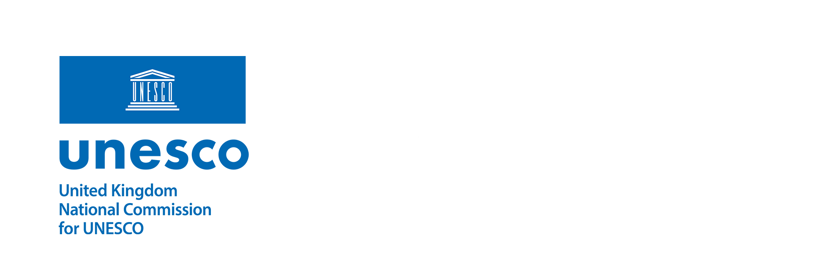 | Secretariat  Suite 98, 3 Whitehall Court  London SW1A 2EL  t: +44 (0)20 7766 3491  amayne@unesco.org.uk  www.unesco.org.uk

TIMELINE FOR UK UNESCO CHAIR AND UNITWIN NETWORK APPLICATION CYCLE 2025

STAGE ONE: Expression of Interest

7 January 2024 Opening of UK UNESCO Chair and UNITWIN Network Programme Application Process

20 and 23 Jan 2025 Proposed Informal Information Webinars

Friday, 31 January 2025 Deadline for Expression of Interest to be sent to UKNC

STAGE TWO: Application

Monday, 3 March 2025 Deadline for Applications to be sent to UKNC (17:00)

4 March to 4 April 2025 Peer Review of Applications (5 weeks)

7 April to 11 April 2025 Applicants provided with anonymised feedback. Applicants can
respond to correct factual information

14 April 2025 UKNC Peer Review Panel to consider applications and reviews

15 April 2025 Candidates informed of outcome

16 April to 25 April 2025 Successful candidates to finalise application as appropriate from
feedback provided

STAGE THREE: Submission to UNESCO

By Wednesday 30 April 2025 Full Applications with letter of endorsement from UKNC
submitted to UNESCO via online platform

