British Academy Writing Workshop for Sub-Saharan African Early Career Researchers (ECRs)

Building on the success of the 2019 British Academy (BA) writing workshop, Professor Juliet Thondhlana, Professor Evelyn Garwe, senior academic mentors and journal editors, in partnership with the Association of African University (AAU) and the British Council Ghana, ran an additional 3-day BA sponsored writing workshop in Accra, Ghana in March 2024.

This workshop, which ran under the UNESCO chair with a view to contributing to [UNESCO’s Operational Strategy for Priority Africa](https://unesdoc.unesco.org/ark:/48223/pf0000382928.locale=en),  aimed to strengthen the research and grant writing, as well as mentoring capacities of alumni, as well as create sustainable networks and train new ECRs. The workshops were inspired by the need to create more impact across the alumni through networking, harnessing, and sharing good practices by those who have done well and strengthening the capacities of those facing challenges. It is hoped that acquiring grant writing skills will enable alumni to secure funding for research, a critical challenge in Sub-Saharan Africa. The additional workshop also provided an opportunity to increase impact by taking on board new ECRs who are being mentored by alumni until March 2025 with the support of senior academic mentors and journal editors.

The emphasis in this round of workshops was on co-planning, peer learning, mentoring, networking, thereby creating an ‘intellectual community’ which can disseminate research through articles publishable in reputable outlets both in Sub-Saharan Africa and beyond. The workshops facilitated and strengthened mutual learning and sustainable partnerships among alumni, new ECRs, senior academic mentors and editors of international journals in the Global South and Global North. Such interaction is intended to strengthen the likelihood of knowledge and work generated by researchers from Sub-Saharan Africa to be recognised, funded, published more widely and cited in international journals where their knowledge and work can contribute to academic debates that shape sustainable futures of development in Africa and globally.

Specific Objectives

* to increase participants’ understanding of the processes, academic writing conventions and dynamics of publishing in international journals;
* to increase participants’ understanding of the democratisation/decolonisation of knowledge;
* to increase participants’ understanding of how best to enhance the visibility of African scholarship;
* to develop participants’ capacity to write for publication;
* to provide an overview of possible grant schemes;
* to develop participants’ skills for writing national and international funding applications;
* to increase participants’ understanding of the importance of mentorship in academic publishing and grant writing;
* to establish sustainable collaborations amongst new ECRs, alumni, senior academic mentors and journal editors.

Editors, Facilitators and Senior Academic Mentors

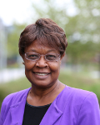

Professor Juliet Thondhlana  
University of Nottingham,  
UK

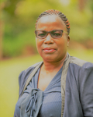

Dr Evelyn Chiyevo  
Garwe

Mohammed VI Polytechnic University, Morocco



Dr Yuwei Xu

University of Nottingham,  
UK

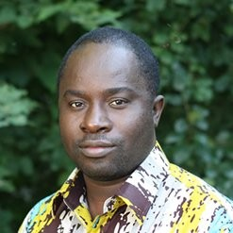

Professor Frederick Ato Armah

Association of African Universities (AAU), Ghana

Dr Unice Goshomi

Women’s University in Africa, Zimbabwe

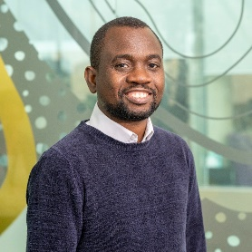

Dr Yinka Somorin

Independent Research Developer



Professor Tony Bush  
University of Nottingham, UK

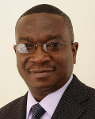

Professor Bill  
Buenar Puplampu  
Central University,   
Ghana



Dr Alicia Bowman

University of Nottingham,  
UK

Mr Harvey Duthie

Belmont Fundraising, Ireland

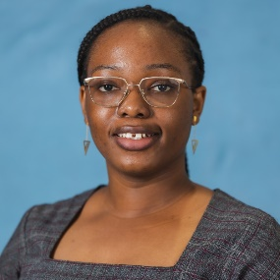

Ms Akorfa Dawson

British Council, Ghana